**Diabetes Prediction Using Machine Learning Techniques**

#### 

# CONTEXT

|  |  |  |
| --- | --- | --- |
| **S.NO** | **DESCRIPTION** | **PAGE NO** |
| 1 | Abstract | 3 |
| 2 | Introduction | 4 |
| 3 | Motivation | 5 |
| 4 | Literature Review | 6-7 |
| 5 | Proposed Methodologies | 8 |
| 6 | Data Pre-processing | 9 |
| 7 | Apply Machine Learning Algorithms | 10-12 |
| 8 | Model Building | 13 |
| 9 | Experimental Analysis | 14 |
| 10 | Conclusion | 15 |
| 11 | References | 16 |
| 12 | Appendix | 17 |

**ABSTRACT**

Diabetes is an illness caused because of high glucose level in a human body. Diabetes should not be ignored if it is untreated then Diabetes may cause some major issues in a person like: heart related problems, kidney problem, blood pressure, eye damage and it can also affect other organs of human body. Diabetes can be controlled if it is predicted earlier. To achieve this goal this project work we will do early prediction of Diabetes in a human body or a patient for a higher accuracy through applying, Various Machine Learning Techniques. Machine learning techniques Provide better result for prediction by con- structing models from datasets collected from patients. In this work we will use Machine Learning Classification and ensemble techniques on a dataset to predict diabetes. Which is K-Nearest Neighbour (KNN), Logistic Regression (LR), Decision Tree (DT), Support Vector Machine (SVM), Gradient Boosting (GB) and Random Forest (RF). The accuracy is different for every model when compared to other models. The Project work gives the accurate or higher accuracy model shows that the model is capable of predicting diabetes effectively. Our Result shows that Random Forest achieved higher accuracy compared to other machine learning techniques.

Keywords: Diabetes, Machine, Learning, Prediction, Dataset, Ensemble

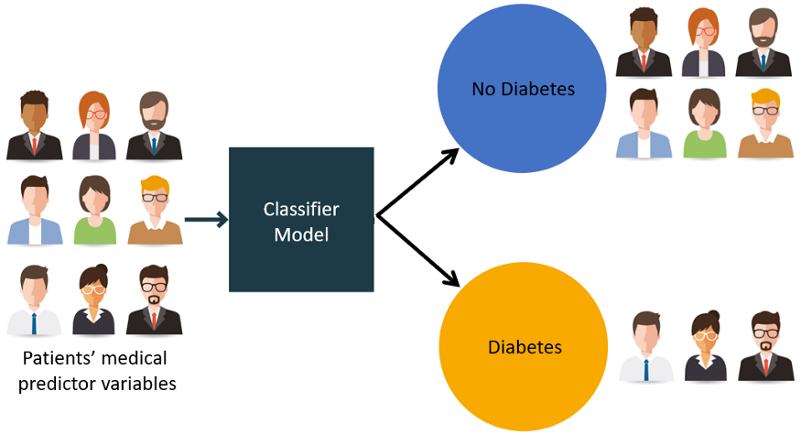

# INTRODUCTION

Diabetes is noxious diseases in the world. Diabetes caused because of obesity or high blood glucose level, and so forth. It affects the hormone insulin, resulting in abnormal metabolism of crabs and improves level of sugar in the blood. Diabetes occurs when body does not make enough insulin. According to (WHO) World Health Organization about 422 million people suffering from diabetes particularly from low- or idle-income countries. And this could be increased to 490 billion up to the year of 2030. However, prevalence of diabetes is found among various Countries like Canada, China, and India etc. Population of India is now more than 100 million so the actual amount of diabetes in India is 40 million. Diabetes is major cause of death in the world. Early prediction of disease like diabetes can be controlled and save the human life. To accomplish this, this work explores prediction of diabetes by taking various attributes related to diabetes disease.

For this purpose, we use the Pima Indian Diabetes Dataset, we apply various Machine Learning classification and ensemble Techniques to predict diabetes. Machine Learning Is a method that is used to train computers or machines explicitly. Various Machine Learning Techniques provide efficient result to collect Knowledge by building various classification and ensemble models from collected dataset.

Such collected data can be useful to predict diabetes. Various techniques of Machine Learning can capable to do prediction, however it’s tough to choose best technique. Thus, for this purpose we apply popular classification and ensemble methods on dataset for prediction.

**MOTIVATION**

There has been drastic increase in rate of people suffering from diabetes since a decade. Current human lifestyle is

the main reason behind growth in diabetes. In current medical diagnosis method, there can be three different types of

errors-

1. The false-negative type in which a patient in reality is already a diabetic patient but test results tell that the person

is not having diabetes.

2. The false-positive type. In this type, patient in reality is not a diabetic patient but test reports say that he/she is a

diabetic patient.

3. The third type is unclassifiable type in which a system cannot diagnose a given case. This happens due to

insufficient knowledge extraction from past data, a given patient may get predicted in an unclassified type.

However, in reality, the patient must predict either to be in diabetic category or non-diabetic category. Such errors

in diagnosis may lead to unnecessary treatments or no treatments at all when required. In order to avoid or reduce

severity of such impact, there is a need to create a system using machine learning algorithm and data mining

techniques which will provide accurate results and reduce human efforts.

Model

The 9th attribute is class variable of each data points. This class variable shows the outcome 0 and 1 for diabetics which indicates positive or negative for diabetics.

# LITERATURE REVIEW

# K.Vijayakumar et al. proposed random Forest algorithm for the Prediction of diabetes develop a system which can perform early prediction of diabetes for a patient with a higher accuracy by using Random Forest algorithm in ma- chine learning technique. The proposed model gives the best results for diabetic prediction and the result showed that the prediction system is capable of predicting the diabetes disease effectively, efficiently and most importantly, instantly. Nonso Nnamoko et al. presented predicting diabetes onset: an ensemble supervised learning approach they used five widely used classifiers are employed for the ensembles and a meta-classifier is used to aggregate their outputs. The results are presented and compared with simi- lar studies that used the same dataset within the literature. It is shown that by using the proposed method, diabetes onset prediction can be done with higher accuracy.

N. Joshi et al. presented Diabetes Prediction Using Machine Learning Techniques aims to predict diabetes via three different supervised machine learning methods in- cluding: SVM, Logistic regression, ANN. This project pro- poses an effective technique for earlier detection of the diabetes disease. Dheeraj Shetty et al. proposed diabetes disease prediction using data mining assemble Intelligent Diabetes Disease Prediction System that gives analysis of diabetes malady utilizing diabetes patient’s database. In this system, they propose the use of algorithms like Bayesian and KNN (K-Nearest Neighbour) to apply on diabetes patient’s database and analyse them by taking various attributes of diabetes for prediction of diabetes disease. Muhammad Azeem Sarwar et al.proposed study on prediction of diabetes using machine learning algorithms in healthcare they applied six different machine learning algorithms Performance and accuracy of the applied algorithms is discussed and compared. Comparison of the different machine learning techniques used in this study reveals which algorithm is best suited for prediction of diabetes.

Diabetes Prediction is becoming the area of interest for researchers in order to train the program to identify the patient are diabetic or not by applying proper classifier on the dataset. Based on previous research work, it has been observed that the classification process is not much im-

proved. Hence a system is required as Diabetes Prediction is important area in computers, to handle the issues identified based on previous research.

**PROPOSED METHODOLOGY**

Goal of the paper is to investigate for model to predict diabetes with better accuracy. We experimented with different classification and ensemble algorithms to predict diabetes. In the following, we briefly discuss the phase.

Dataset Description- the data is gathered from UCI repository which is named as Pima Indian Diabetes Dataset. The dataset has many attributes of 768 patients.

Table 1: Dataset Description

|  |  |
| --- | --- |
| S No. | Attributes |
| 1 | Pregnancy |
| 2 | Glucose |
| 3 | Blood Pressure |
| 4 | Skin thickness |
| 5 | Insulin |
| 6 | BMI (Body Mass Index) |
| 7 | Diabetes Pedigree Function |
| 8 | Age |

The 9th attribute is class variable of each data points. This class variable shows the outcome 0 and 1 for diabetics which indicates positive or negative for diabetics.

Distribution of Diabetic patient- We made a model to predict diabetes however the dataset was slightly imbalanced having around 500 classes labelled as 0 means negative means no diabetes and 268 labelled as 1 means positive means diabetic.

Figure 1: Ratio of Diabetic and Non-Diabetic Patient

**Data Preprocessing**

Data pre-processing is most im- portent process. Mostly healthcare related data contains missing vale and other impurities that can cause effective- ness of data. To improve quality and effectiveness obtained after mining process, Data pre-processing is done. To use Machine Learning Techniques on the dataset effectively this process is essential for accurate result and successful prediction. For Pima Indian diabetes dataset, we need to perform pre-processing in two steps.

**Missing Values removal-** Remove all the instances that have zero (0) as worth. Having zero as worth is not possible. Therefore, this instance is eliminated. Through eliminating irrelevant features/instances we make feature subset and this process is called features subset selection, which reduces dimensionality of data and help to work faster.

**Splitting of data-** After cleaning the data, data is normalized in training and testing the model. When data is spitted then we train algorithm on the training data set and keep test data set aside. This training process will produce the training model based on logic and algorithms and values of the feature in training data. Basically, aim of normalization is to bring all the attributes under same scale.

**Apply Machine Learning**

When data has been ready, we apply Machine Learning Technique. We use different classification and ensemble techniques, to predict diabetes. The methods applied on Pima Indians diabetes dataset. Main objective to apply Machine Learning Techniques to analyse the performance of these methods and find accuracy of them, and also been able to figure out the responsible/important feature which play a major role in prediction. The Techniques are follows-

**K-Nearest Neighbour** –

KNN is also a supervised ma- chine learning algorithm. KNN helps to solve both the classification and regression problems. KNN is lazy prediction technique. KNN assumes that similar things are near to each other. Many times, data points which are similar are very near to each other. KNN helps to group new work based on similarity measure. KNN algorithm record all the records and classify them according to their similarity measure. For finding the distance between the points uses tree like structure. To make a prediction for a new data point, the algorithm finds the closest data points in the training data set its nearest neighbours. Here K= Number of nearby neighbours, it’s always a positive integer. Neighbours value is chosen from set of class. Closeness is mainly defined in terms of Euclidean distance. The Euclidean distance between two points P and Q i.e. P (p1,p2, . Pn) and Q (q1, q2,..qn) is defined by the following equation:-

Algorithm-

* Take a sample dataset of columns and rows named as Pima Indian Diabetes data set.
* Take a test dataset of attributes and rows.
* Find the Euclidean distance by the help of formula Then, decide a random value of K. is the no. of nearest neighbours,
* Then with the help of these minimum distance and Euclidean distance find out the nth column of each.
* Find out the same output values.
* If the values are same, then the patient is diabetic, other- wise not.

**Logistic Regression-**

Logistic regression is also a supervised learning classification algorithm. It is used to estimate the probability of a binary response based on one or more predictors. They can be continuous or discrete. Logistic regression used when we want to classify or distinguish some data items into categories.

It classifies the data in binary form means only in 0 and 1 which refer case to classify patient that is positive or negative for diabetes.

Main aim of logistic regression is to best fit which is responsible for describing the relationship between target and predictor variable. Logistic regression is a based on Linear regression model. Logistic regression model uses sigmoid function to predict probability of positive and negative class.

Sigmoid function P = 1/1+e – (a+bx) Here P = probability, a and b = parameter of Model.

**Ensembling-** Ensembling is a machine learning technique Ensemble means using multiple learning algorithms together for some tasks. It provides better prediction than any other individual model that’s why it is used. The main cause of error is noise bias and variance, ensemble methods help to reduce or minimize these errors. There are two popular ensemble methods such as Bagging, Boosting, ada-boosting, Gradient boosting, voting, averaging etc. Here In this work, we have used Bagging (Random Forest) and Gradient boosting ensemble methods for predicting diabetes.

**Random Forest**

It is type of ensemble learning method and also used for classification and regression tasks. The accuracy it gives is grater then compared to other models. This method can easily handle large datasets. Random Forest is developed by Leo Bremen. It is popular ensemble Learning Method. Random Forest Improve Performance of Decision Tree by reducing variance. It operates by constructing a multitude of decision trees at training time and outputs the class that is the mode of the classes or classification or mean prediction (regression) of the individual trees.

Algorithm-

* The first step is to select the R features from the total features m where R<<M.
* Among the R features, the node using the best split point.
* Split the node into sub nodes using the best split.
* Repeat a to c steps until l number of nodes has been reached.
* Built forest by repeating steps a to d for a num- ber of times to create n number of trees.

The random forest finds the best split using the Gin-Index Cost Function which is given by:

The first step is to need the take a glance at choices and use the foundations of each indiscriminately created decision tree to predict the result and stores the anticipated outcome at intervals the target place. Secondly, calculate the votes for each predicted target and ultimately, admit the high voted predicted target as a result of the ultimate prediction from the random forest formula. Some of the options of Random Forest does correct predictions result for a spread of applications are offered.

**MODEL BUILDING**

This is most important phase which includes model building for prediction of diabetes. In this we have implemented various machine learning algorithms which are discussed above for diabetes prediction.

**Procedure of Proposed Methodology-**

**Step1:** Import required libraries, Import diabetes dataset.

**Step2:** Pre-process data to remove missing data.

**Step3:** Perform percentage split of 80% to divide dataset as Training set and 20% to Test set.

**Step4:** Select the machine learning algorithm i.e., K- Nearest Neighbour, Support Vector Machine, Decision Tree, Logistic regression, Random Forest and Gradient boosting algorithm.

**Step5:** Build the classifier model for the mentioned ma- chine learning algorithm based on training set.

**Step6:** Test the Classifier model for the mentioned ma- chine learning algorithm based on test set.

**Step7:** Perform Comparison Evaluation of the experimental performance results obtained for each classifier.

**Step8:** After analysing based on various measures conclude the best performing algorithm.

**EXPERIMENTAL RESULTS**

In this work different steps were taken. The proposed approach uses different classification and ensemble methods and implemented using python. These methods are standard Machine Learning methods used to obtain the best ac- curacy from data. In this work we see that random forest classifier achieves better compared to others. Overall, we have used best Machine Learning techniques for prediction and to achieve high performance accuracy. Figure shows the result of these Machine Learning methods.

Figure3: Accuracy Result of Machine learning methods

Here feature played important role in prediction is present- ed for random forest algorithm. The sum of the importance of each feature playing major role for diabetes have been plotted, where X-axis represents the importance of each feature and Y-Axis the names of the features.

**Deployment Using Streamlit**

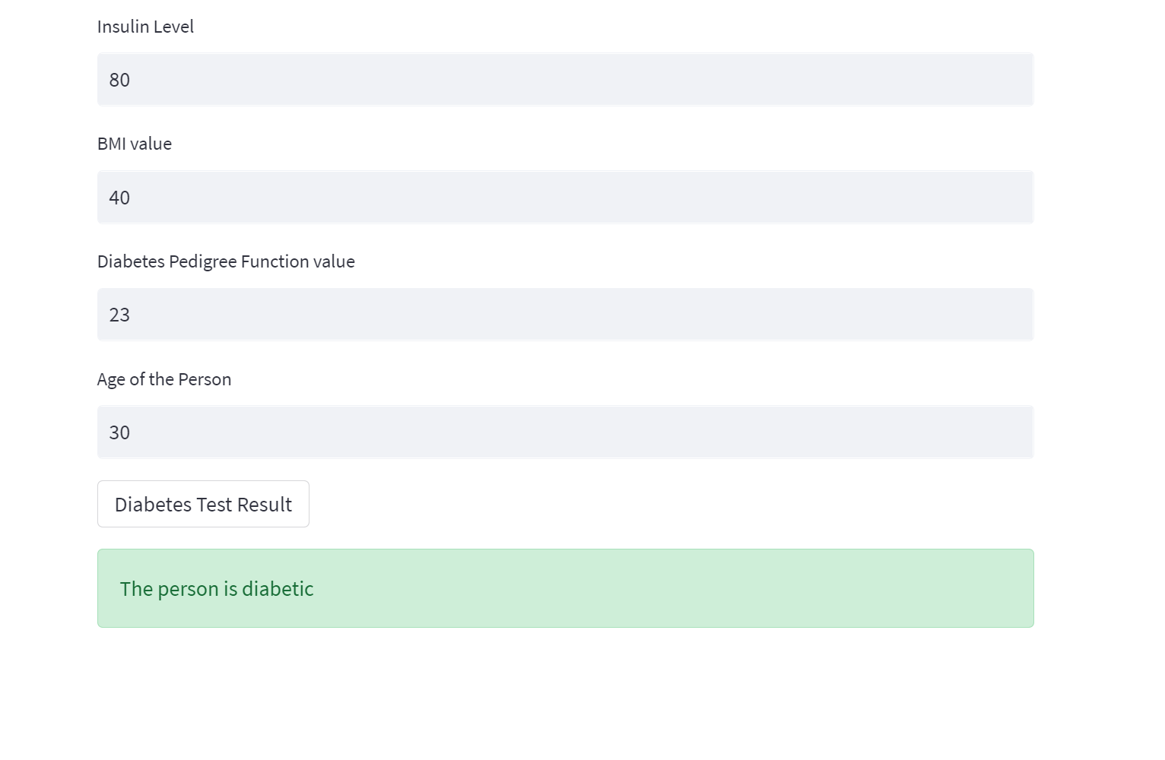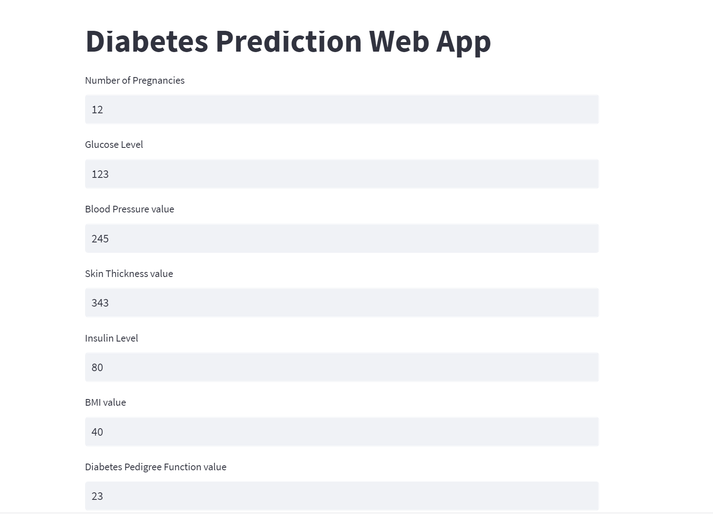

**CONCLUSION**

The main aim of this project was to design and implement Diabetes Prediction Using Machine Learning Methods and Performance Analysis of that methods and it has been achieved successfully. The proposed approach uses various classification and ensemble learning method in which Knn, Random Forest, Decision Tree, Logistic Regression and Naïve Bayes are used. And 77% classification accuracy has been achieved. The Experimental results can be asst health care to take early prediction and make early decision to cure diabetes and save humans life.

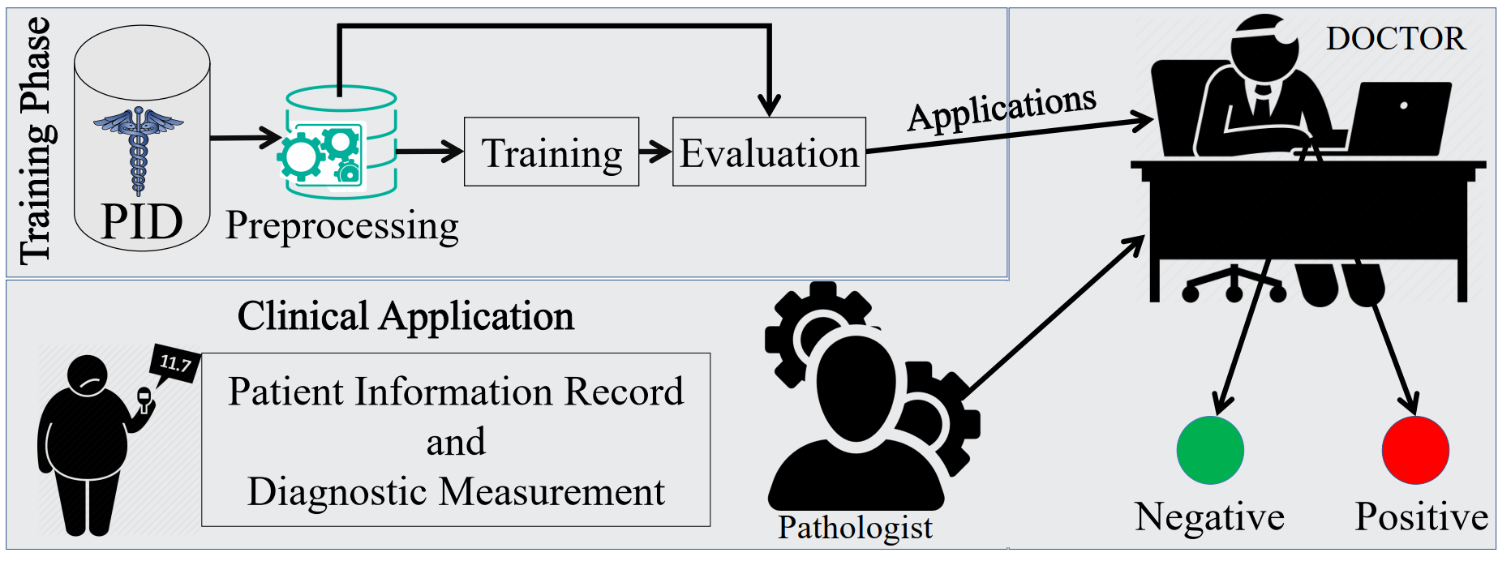

**REFERENCES**

Debadri Dutta, Debpriyo Paul, Parthajeet Ghosh, "Analyzing Feature Importances for Diabetes Prediction using Machine Learning". IEEE, pp 942-928, 2018.

K.VijiyaKumar, B.Lavanya, I.Nirmala, S.Sofia Caroline, "Random Forest Algorithm for the Prediction of Diabetes ".Proceeding of International Conference on Systems Compu- tation Automation and Networking, 2019.

Md. Faisal Faruque, Asaduzzaman, Iqbal H. Sarker, "Perfor- mance Analysis of Machine Learning Techniques to Predict Diabetes Mellitus". International Conference on Electrical, Computer and Communication Engineering (ECCE), 7-9 Feb- ruary, 2019.

Tejas N. Joshi, Prof. Pramila M. Chawan, "Diabetes Prediction Using Machine Learning Techniques".Int. Journal of Engineer- ing Research and Application, Vol. 8, Issue 1, (Part -II) Janu- ary 2018, pp.-09-13

Nonso Nnamoko, Abir Hussain, David England, "Predicting Diabetes Onset: an Ensemble Supervised Learning Approach ". IEEE Congress on Evolutionary Computation (CEC), 2018.

Deeraj Shetty, Kishor Rit, Sohail Shaikh, Nikita Patil, "Diabe- tes Disease Prediction Using Data Mining ".International Con- ference on Innovations in Information, Embedded and Com- munication Systems (ICIIECS), 2017.

Nahla B., Andrew et al,"Intelligible support vector machines for diagnosis of diabetes mellitus. Information Technology in Biomedicine", IEEE Transactions. 14, (July. 2010), 1114-20.

A.K., Dewangan, and P., Agrawal, Classification of Diabetes Mellitus Using Machine Learning Techniques, International Journal of Engineering and Applied Sciences, vol. 2, 2015.

# APPENDIX

### Resources for Covid-19 Analysis

* Kaggle website.
* Python.
* Machine Learning
* Jupyter notebook